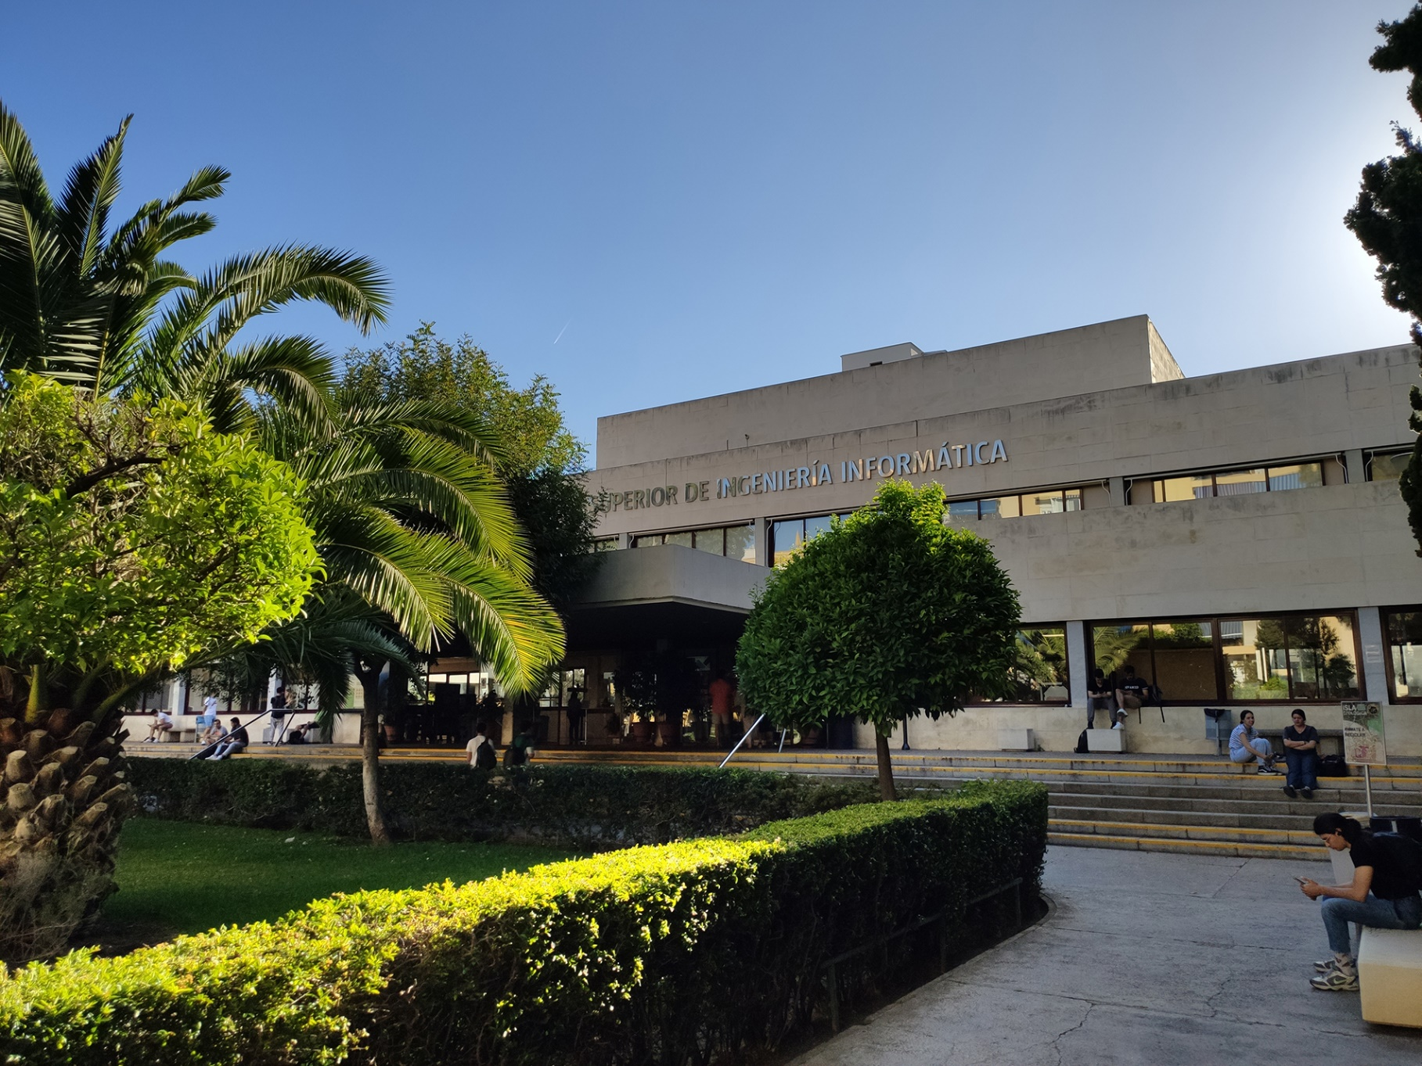

|  |
| --- |
| Analysis Report |
| Jesús Cárdenas Conejo  (jescarcon@alum.us.es) |
| 17-02-2023  Group: C1.02.10  Repository: https://github.com/jescarcon/Acme-L3-D01-23.1 |



Table of Contents

Executive Summary 3

Version History 4

Introduction 5

Contents 6

Conclusions 7

Bibliography 8

# Executive Summary

In this report you will find relative information of my first deliverable in an Analysis Report structure. This document shows how many analyses record I have redacted, the content of those reports and a link to the forum where a lecturer gave us insight, if the requirement needed an outside help for interpretation.

# Version History

|  |  |  |
| --- | --- | --- |
| Version | Date | Description of changes |
| V1.0 | 16/02/2023 | Creation of the Analysis Report Document |

# Introduction

In this report I am going to describe the analysis and decision that I have made in the process of finding a solution for the problems that are stated on the deliverable 1.

I will explain how I understand the requirement from the original statement I copy from the document and how I did it in a short way. I commit a mistake in the comprehension of the requirement and that let me just waiting the lab day for answer my doubt , as I explain later, I will use the forum and provide the link to the discussion for improving next deliverable way to analysis. At the end I add a note referring to the rest of requirements ( Reports) .

# Contents

Analysis of Individual Requirement #1:

Statement:

*“Modify the anonymous menu so that it shows an option that takes the browser to the home page of your favourite web site. The title must read as follows: “〈id-number〉: 〈surname〉, 〈name〉”, where “〈id-number〉” denotes your DNI, NIE, or passport number, “〈surname〉” denotes your surname/s, and “〈name〉” denotes your name/s.”*

After the reading and analysis of the statement I understand that I have to work in my own branch to do the task and then merge it with the others , but I thought I have to change the word “Anonymous” to my name and DNI and add my favorite link below , what will cause conflicts with my partners. Fortunately, the professor resolve my doubt in time.

So the work as I understand was about modify the link associated to me (creating new one as the anonymous example) in menu.jsp and finally adding my name and dni in both files menu-es.i18n and menu-en.i18n.

The professor told us that the proper way to resolve the doubts was in the forum that I will use more often definitely.

Note: The requirements about doing the Reports was easy and no needed to comment nothing about them, I just follow the lecturer docs to fill them.

# Conclusions

This first requirement is quite easy for the beginning, it was trying to get a first sight of how working in teams is, but I have failed interpreting some of requirements. We will check the forum to get the correct analysis for the futures deliverables.

# Bibliography

Intentionally blank.